List of Assistive Listening Systems in _______Community (Template)
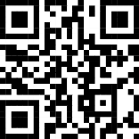
Below is a list of all assistive listening systems in our community. For information on how to use, see your audiologist, hearing instrument specialist, or facility website. See webpage: How to use
City Name 3
- Church name (HL)
- Church name (FM)
- Church name (Auracast)
- City Council (FM)
- Courts (IR)
- City offices (HL)
- Theatre name (FM)
- JCC (Hearing Loop)
- Library Theater (FM)
- Movie Theater (IR)
- Senior Center (FM)
- Synagogue name (HL)
- University theater (FM)
- Performing arts (Auracast)
City Name 1
- Church name (HL)
- Church name (FM)
- Church name (Auracast)
- County Commission Hearing Room (FM)
- Courts (IR)
- City offices (HL)
- Theatre name (FM)
- JCC (Hearing Loop)
- Library Theater (FM)
- Movie Theater (IR)
- Senior Center (HL)
- Synagogue name (HL)
- University theater (FM)
- Performing arts (Auracast)
City Name 2
- Church name (HL)
- Church name (FM)
- Courts (IR)
- City offices (FM)
- Library meeting room (FM)
- Movie Theater (IR)

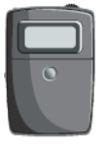
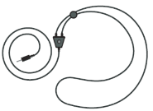
Neckloop and receiver

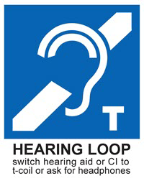 | Hearing Loop (HL)  - Individuals with telecoils in their hearing devices: NO equipment to check out.  - Individuals without hearing aids: borrow a receiver and headphones.
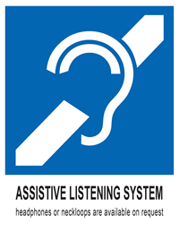 | FM/RF and Infrared (IR)  - Individuals with telecoils in their hearing devices: borrow a receiver and neckloop.  - Individuals without telecoils in their hearing devices: borrow a receiver and headphones.
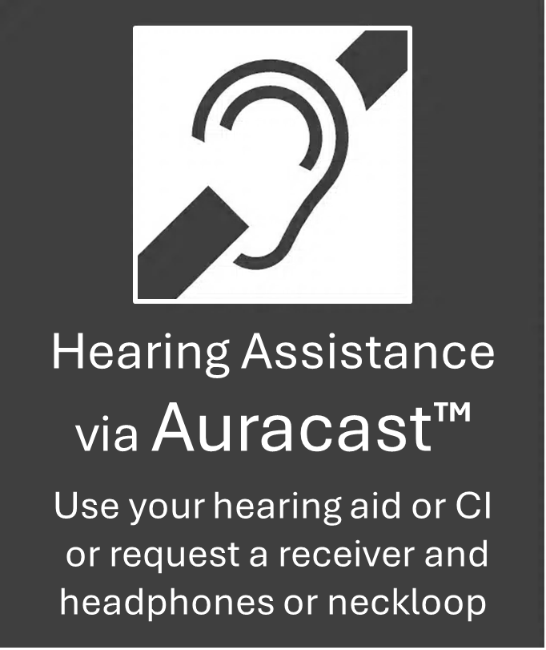 | Auracast Streamed Assistive Listening  - Individuals with Auracast in their hearing devices – use your phone to connect.  - Individuals with telecoils in their hearing devices: borrow a receiver and neckloop.  - Individuals without telecoils in their hearing devices: borrow a receiver and headphones.  - Individuals with Auracast in their earbuds or headphones: use your phone to connect.
Template Purpose: An outline to create an easy, local list of all assistive listening systems
Audience: Consumers, audiologists, hearing instrument specialists

Template courtesy of the Center for Hearing Access. For other templates, sample language, free graphics, and further info, visit https://centerforhearingaccess.org

