Center for Hearing Access

How to Use Assistive Listening Systems

Intent
Option B
- Hearing instruments Without a telecoil
- Without hearing instruments
Borrow a receiver and headphones from the facility
Purpose: Basic instructions to use a hearing loop, FM/RF, or infrared assistive listening system.
Audience: people with disabilities, such as hearing loss, low vision, ADHD, etc.

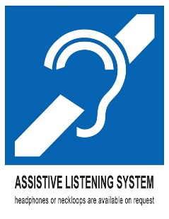

Overview
These systems bring amazing clarity by bringing the presenter’s voice directly to your ear. There are hundreds of these systems throughout your state, across the country, and around the world. Under the ADA, the following places are required to have these systems.
- In ALL indoor or outdoor areas or rooms, with a public address system, including arenas, classrooms, convention centers​, lecture halls, movie theaters, performing arts centers, public hearing rooms​, public meeting rooms, etc.
- In all courtrooms.
- In areas where “Effective Communication” is needed, such as service counters, rooms without public address systems, meetings, parent/teacher conferences, and similar settings.

Option A. No hearing aids or hearing aids WITHOUT a telecoil
- Borrow a receiver and headphones, earbuds, or single-sided ear speaker from the facility.
Put headphones on top of the hearing aids, not the opening of your ear. If you or others hear a “squealing” sound, it is caused by feedback between the headphones and hearing aid. Try adjusting the location of the headphones.

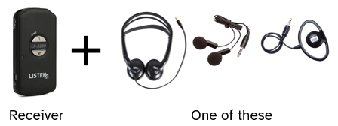

Option B. Hearing instruments WITH a telecoil
1a. Hearing loop: no equipment to borrow from the facility! Your receiver is your telecoil! Or
1b. FM/RF or infrared. Borrow a receiver and neckloop from the facility.
- Switch to your telecoil program. Depending on your device, you can adjust your microphone (M) and telecoil (T) settings.
  - 50% M / 50% T mixture for conversation awareness. You can visit with the person next to you and still receive the sound through your telecoil.
  - 100% T to focus entirely on the speaker and decrease loud background sounds.

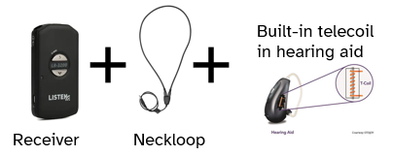

Resources
a) Video using the equipment (2 minutes)
b) further, multiple resources on how to use

About the Center for Hearing Access
Founded in 2024, the nonprofit Center for Hearing Access is a national advocacy and education initiative of The John G. Shedd Institute. We champion and educate users, facility staff, audiologists, and hearing instrument specialists about all ADA-compliant assistive listening systems and other strategies to increase access to public places. Effective hearing access can be life-changing for people with hearing loss to maintain community engagement.

Graphics credits: WilliamsAV

Rev. 3/5/25, 1/5/26

