Center for Hearing Access

Audio Description and Assistive Listening Devices and Connections:

Draft Requirements for DeafBlind and Low Vision Users

January 6, 2026 Version 1
March 1, 2026, version 2, small revisions

Observations and Suggestions by Center for Hearing Access
A very rough draft

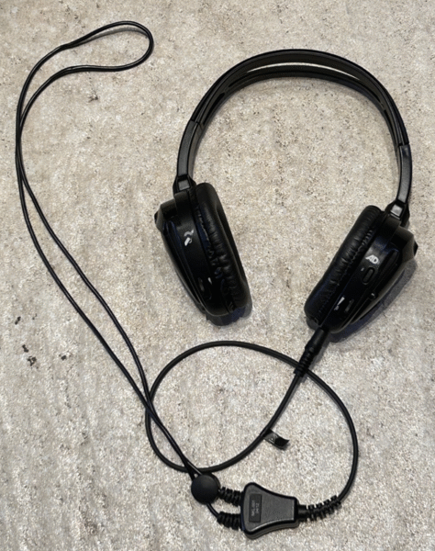

Image Description: Circumaural headphones with Audio Description (AD) for one ear and assistive listening for the other ear. Current status: headphones used in Cinemark theaters, one manufacturer only (Q-SYS), headphones are discontinued.

Intro
The purpose of this document is to raise awareness of unaddressed needs. If DeafBlind and low vision advocates wish to adopt and use this document to lead educational and advocacy efforts, they are welcome to do so without permission. The Center for Hearing Access can provide some assistance.

Equipment and Connectivity Requirements
While these features are needed, there are no current capabilities with existing, current equipment (hearing loop, FM/RF, infrared), and the future with Auracast streamed assistive listening systems (ALS).
- One combined receiver device. Need: To simultaneously stream AD and ALS into one device, with separate volume controls
  - Facility-owned equipment that consumers borrow. Examples:
    - One existing product. An infrared system no longer manufactured Q-SYS equipment (image and description on this page)
    - All other current ALS. Other systems require the user to borrow two separate devices.
    - Auracast ALS. Single stream only in receivers. Requires the user to borrow two separate devices
  - Hearing aids. The ability to simultaneously receive: 1) one hearing aid with AD and 2) the other hearing aid for assistive listening.
    - Current: no known capabilities.
    - Auracast feature in hearing aid – no mention at this point in time.

- Independent controls.
  - Need to eliminate small control designs and provide good tactile control/ feedback (channel or stream selection and volume selection)
    - Current ALS receivers. Limited and somewhat problematic.
    - Auracast ALS receivers.
      - Problem: Some Auracast receiver controls have a screen that is inaccessible to people with low vision.
      - Auracast receivers are small:
- Listen/Ampetronic (Auri): 3.54 x 2.13 x 0.91 inches (90 x 52 x 16mm)
- WilliamsAV (Infinium): 3.9″ x 2.48″ x 0.85″ (99 x 63 x 21.6 mm)
- Bettear (B-RTX transceiver): 4.25” x 2.28” x 0.94 inches (108 x 58 x 24 mm)

- Auracast AD-Definition of stream itself. No standards or even an industry-agreed practice.
  - Consistent naming of the stream identification of AD stream, so consumers know what stream to find and select anywhere in the world.
  - AD stream audio quality. Specify to use only 16 or 24 kHz streams for hearing aid/cochlear implant compatibility.
  - AD transmitter requirements:
    - AGC required to maintain a consistent sound level
    - A two-channel device (so automatically enables simultaneous ALS and AD streams to be transmitted).
    - A mic input for AD and line level audio input for ALS (from sound system)
  - Microphone
    - The microphone for the AD input, needs to be fitted with a local on/off or mute control which the user (Describer) can readily operate to mute the microphone

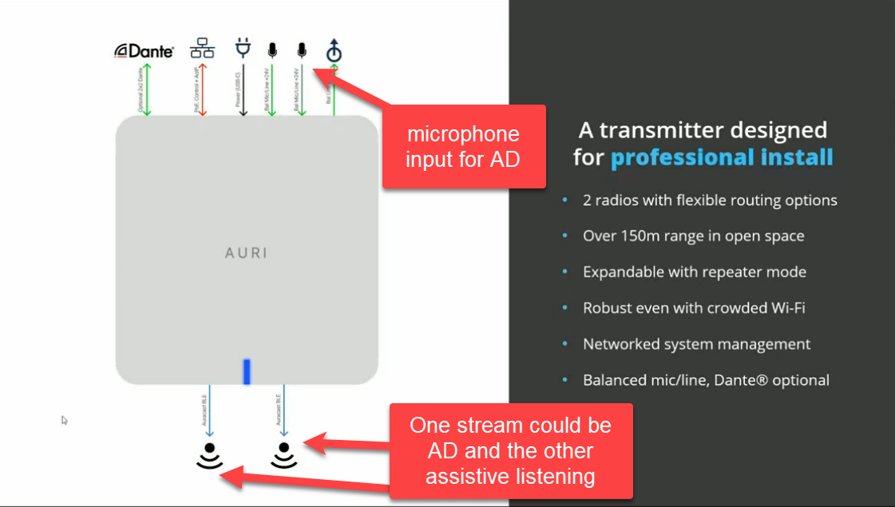
Graphic description: Auri transmitter showing
1) inputs of Dante, two microphones, and audio in. Added comment in red : "microphone input for AD"
2) outputs of two streams. Added comment in red:: "One stream could be AD and the other assistive listening"

On the right is a list of the capabilities
- A transmitter designed for professional install
- 2 radios with flexible routing options
- Over 150m range in open space
- Expandable with repeater mode
- Robust even with crowded Wi-Fi
- Networked system management
- Balanced mic/line, Dante(r) optional
Illustration. Auri transmitter by Listen/Ampetronic
Graphic credit: (Apr 16, 2025) Introduction to Auracast Bluetooth – Accessible Audio for All for RTIG

- Auracast-Direct hearing aid connection. Auracast ALS requires an intermediary device, such as a smartwatch or smartphone to select streams. There is no single hearing aid button to select ALS, which adds complexity for Auracast ALS. Comparison: for telecoils used with current ALS, it is a single-button selection on hearing aids for the telecoil program.

Resource-Declaration of Needs
From Center for Hearing Access, “U.S. Declaration ADA-Access-Ready Hearing Instruments Auracast™ and Telecoils, December 2024
- Pdf version
- Word version

Relevant excerpts:
- 1d. Produce direct-to-hearing instrument connections. No intermediary control or “handshake” device should be required to access the ALS nor should a receiver with a neckloop be required. Intermediary devices add complexity and barriers for individuals with limited dexterity, limited cognitive abilities, or limited tech familiarity.
- 4b. Produce equipment that maximizes comfort, sanitation, and usability for users.
  - ii. Produce functionality for the DeafBlind community. Audio description and ALS need to work easily and in tandem.
- 4d. Provide evidence of claimed capabilities for produced equipment by practical, reputable third parties that include people with hearing loss and DeafBlind.

